BANK LOAN REPORT ANALYSIS
PROBLEM STATEMENT AND PROJECT OBJECTIVE
The bank currently lacks a centralized, real-time view of its loan performance across key financial and risk indicators. Decision makers are unable to easily track trends in Total Loan Applications, Total Funded Amount, Total Amount Received, Average Interest Rate and Average Debt-to-Income Ratio on a Month-to-Date (MTD) and Month-over-Month (MoM) basis. This limitation reduces the bank’s ability to assess growth, profitability, and borrower risk in a timely manner. This project aims to develop an interactive analytical report that provides clear insights into monthly performance trends and supports data-driven lending decisions.

DATASET SUMMARY
Data Source – Kaggle
- Rows – 38,576
- Columns – 24
- Some Key Features – Address state, Employment Length, Grade, Home Ownership, Issue Date, Last Payment Date, Next Payment Date, Loan Status, Purpose, Term, DTI, Interest Rate, Loan Amount and Total Payment.

TOOLS AND TECHNIQUES
- Kaggle API/CSV download
- Power BI

EXPLORATORY DATA ANALYSIS USING POWER BI
We begin with importing our CSV file into Power BI, then click on Load or Transform Data for cleaning in power query to check for the data quality.
- Checked for column data types
- Handled missing values
- Checked for duplicates
- Create a new table (We create a new ‘Date’ table)
- Create new measures (Month-To-Date, Previous Month-To-Date, Month-Over-Month, Average Interest Rates, Average DTI and Good Loans and Bad Loans)

DATA ANALYSIS OF KPIs USING POWER BI
- Total Loan Applications

- MTD Loan Applications

- MoM Loan Applications

- PMTD Loan Applications

- Total Funded Amount

- MTD Funded Amount

- MoM Funded Amount

- PMTD Funded Amount

- Total Amount Received

- MTD Amount Received

- MoM Amount Received

- PMTD Amount Received

- Average Interest Rate

- MTD Average Interest Rate

- MoM Average Interest Rate

- PMTD Average Interest Rate

- Average DTI

- MTD Average DTI

- MoM Average DTI

- PMTD Average DTI

- Good Loan Applications

- Good Loan Funded Amount

- Good Loan Amount Received

- Good Loan Percentage

- Bad Loan Applications

- Bad Loan Funded Amount

- Bad Loan Amount Received

- Bad Loan Percentage

DASHBOARD 1 IN POWER BI: SUMMARY
Key Performance Indicators (KPIs) Requirements:
- Total Loan Applications: We need to calculate the total number of loan applications received during a specified period. Additionally, it is essential to monitor the Month-to-Date (MTD) Loan Applications and track changes Month-over-Month (MoM).
- Total Funded Amount: Understanding the total amount of funds disbursed as loans is crucial. We also want to keep an eye on the MTD Total Funded Amount and analyse the Month-over-Month (MoM) changes in this metric.
- Total Amount Received: Tracking the total amount received from borrowers is essential for assessing the bank's cash flow and loan repayment. We should analyse the Month-to-Date (MTD) Total Amount Received and observe the Month-over-Month (MoM) changes.
- Average Interest Rate: Calculating the average interest rate across all loans, MTD, and monitoring the Month-over-Month (MoM) variations in interest rates will provide insights into our lending portfolio's overall cost.
- Average Debt-to-Income Ratio (DTI): Evaluating the average DTI for our borrowers helps us gauge their financial health. We need to compute the average DTI for all loans, MTD, and track Month-over-Month (MoM) fluctuations.

Good Loan v Bad Loan KPI’s
In order to evaluate the performance of our lending activities and assess the quality of our loan portfolio, we need to create a comprehensive report that distinguishes between 'Good Loans' and 'Bad Loans' based on specific loan status criteria
Good Loan KPIs:
- Good Loan Application Percentage: We need to calculate the percentage of loan applications classified as 'Good Loans.' This category includes loans with a loan status of 'Fully Paid' and 'Current.'
- Good Loan Applications: Identifying the total number of loan applications falling under the 'Good Loan' category, which consists of loans with a loan status of 'Fully Paid' and 'Current.'
- Good Loan Funded Amount: Determining the total amount of funds disbursed as 'Good Loans.' This includes the principal amounts of loans with a loan status of 'Fully Paid' and 'Current.'
- Good Loan Total Received Amount: Tracking the total amount received from borrowers for 'Good Loans,' which encompasses all payments made on loans with a loan status of 'Fully Paid' and 'Current.'

Bad Loan KPIs:
- Bad Loan Application Percentage: Calculating the percentage of loan applications categorized as 'Bad Loans.' This category specifically includes loans with a loan status of 'Charged Off.'
- Bad Loan Applications: Identifying the total number of loan applications categorized as 'Bad Loans,' which consists of loans with a loan status of 'Charged Off.'
- Bad Loan Funded Amount: Determining the total amount of funds disbursed as 'Bad Loans.' This comprises the principal amounts of loans with a loan status of 'Charged Off.'
- Bad Loan Total Received Amount: Tracking the total amount received from borrowers for 'Bad Loans,' which includes all payments made on loans with a loan status of 'Charged Off.'

Loan Status Grid View
In order to gain a comprehensive overview of our lending operations and monitor the performance of loans, we aim to create a grid view report categorized by 'Loan Status.' This report will serve as a valuable tool for analysing and understanding the key indicators associated with different loan statuses. By providing insights into metrics such as 'Total Loan Applications,' 'Total Funded Amount,' 'Total Amount Received,' 'Month-to-Date (MTD) Funded Amount,' 'MTD Amount Received,' 'Average Interest Rate,' and 'Average Debt-to-Income Ratio (DTI),' this grid view will empower us to make data-driven decisions and assess the health of our loan portfolio.

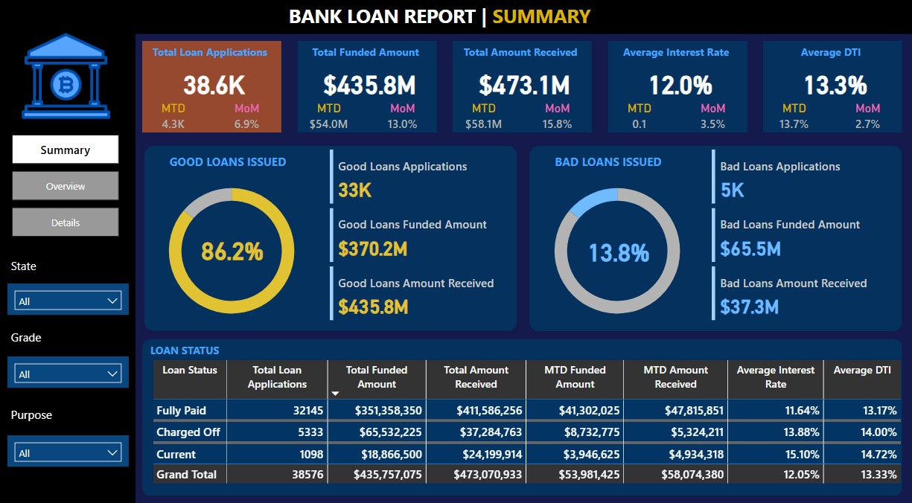

DASHBOARD 2 IN POWER BI: OVERVIEW
In our Bank Loan Report project, we aim to visually represent critical loan-related metrics and trends using a variety of chart types. These charts will provide a clear and insightful view of our lending operations, facilitating data-driven decision-making and enabling us to gain valuable insights into various loan parameters. Below are the specific chart requirements:
1. Monthly Trends by Issue Date (Line Chart):
Chart Type: Line Chart
Metrics: 'Total Loan Applications,' 'Total Funded Amount,' and 'Total Amount Received'
X-Axis: Month (based on 'Issue Date')
Y-Axis: Metrics' Values
Objective: This line chart will showcase how 'Total Loan Applications,' 'Total Funded Amount,' and 'Total Amount Received' vary over time, allowing us to identify seasonality and long-term trends in lending activities.
2. Regional Analysis by State (Filled Map):
Chart Type: Filled Map
Metrics: 'Total Loan Applications,' 'Total Funded Amount,' and 'Total Amount Received'
Geographic Regions: States
Objective: This filled map will visually represent lending metrics categorized by state, enabling us to identify regions with significant lending activity and assess regional disparities.
3. Loan Term Analysis (Donut Chart):
Chart Type: Donut Chart
Metrics: 'Total Loan Applications,' 'Total Funded Amount,' and 'Total Amount Received'
Segments: Loan Terms (e.g., 36 months, 60 months)
Objective: This donut chart will depict loan statistics based on different loan terms, allowing us to understand the distribution of loans across various term lengths.
4. Employee Length Analysis (Bar Chart):
Chart Type: Bar Chart
Metrics: 'Total Loan Applications,' 'Total Funded Amount,' and 'Total Amount Received'
X-Axis: Employee Length Categories (e.g., 1 year, 5 years, 10+ years)
Y-Axis: Metrics' Values
Objective: This bar chart will illustrate how lending metrics are distributed among borrowers with different employment lengths, helping us assess the impact of employment history on loan applications.
5. Loan Purpose Breakdown (Bar Chart):
Chart Type: Bar Chart
Metrics: 'Total Loan Applications,' 'Total Funded Amount,' and 'Total Amount Received'
X-Axis: Loan Purpose Categories (e.g., debt consolidation, credit card refinancing)
Y-Axis: Metrics' Values
Objective: This bar chart will provide a visual breakdown of loan metrics based on the stated purposes of loans, aiding in the understanding of the primary reasons borrowers seek financing.

6. Home Ownership Analysis (Tree Map):
Chart Type: Tree Map
Metrics: 'Total Loan Applications,' 'Total Funded Amount,' and 'Total Amount Received'
Hierarchy: Home Ownership Categories (e.g., own, rent, mortgage)
Objective: This tree map will display loan metrics categorized by different home ownership statuses, allowing for a hierarchical view of how home ownership impacts loan applications and disbursements.
These diverse chart types will enhance our ability to visualize and communicate loan-related insights effectively, supporting data-driven decisions and strategic planning within our lending operations."

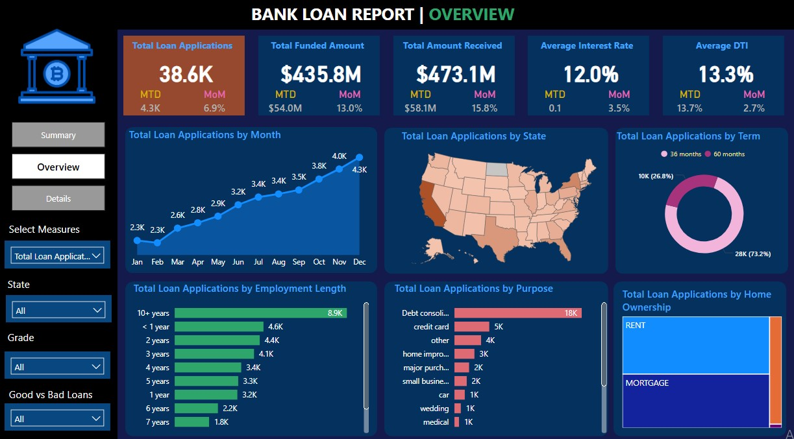

DASHBOARD 3 IN POWER BI: DETAILS
In our Bank Loan Report project, we recognize the need for a comprehensive 'Details Dashboard' that provides a consolidated view of all the essential information within our loan data. This Details Dashboard aims to offer a holistic snapshot of key loan-related metrics and data points, enabling users to access critical information efficiently.
Objective:
The primary objective of the Details Dashboard is to provide a comprehensive and user-friendly interface for accessing vital loan data. It will serve as a one-stop solution for users seeking detailed insights into our loan portfolio, borrower profiles, and loan performance.
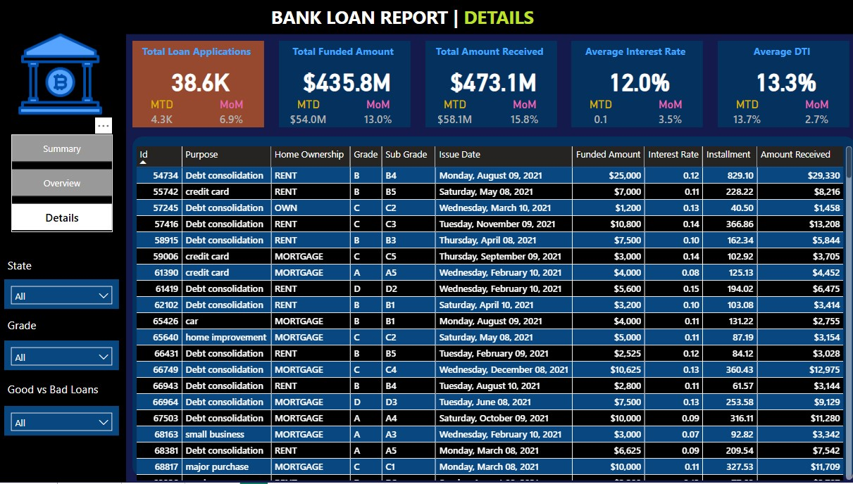

RECOMMENDATIONS
- Promote loan purposes with historically lower default rates through targeted marketing.
- Increase lending focus in states with higher good-loan ratios and stronger repayment performance.
- Set MoM growth targets that are tied to acceptable bad-loan ratios.
- Strengthen credit screening by prioritizing applicants with lower DTI ratios and strong repayment history.
- Align marketing campaigns with borrower segments and regions that show higher approval to good loan conversion.

